**NYC Taxi Data Project Using Microsoft Fabric**

Overall Project Architecture,

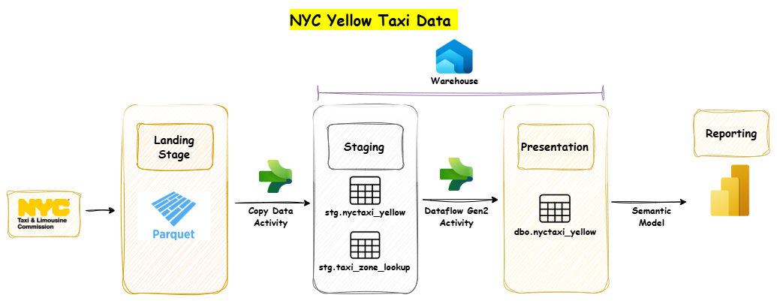

Create Fabric Workspace by providing relevant name for the workspace.

Create Lakehouse as ‘ProjectLakehouse’.

Go to the Lake house and Create sub folders under the Files folder as ‘nyctaxi_lookup_zone’ and ‘nyctaxi_yellow’. Upload Yellow trip data Parquet files to the ‘nyctaxi_yellow’ folder and Upload taxi_zone_lookup.csv file to the ‘nyctaxi_lookup_zone’ folder.

